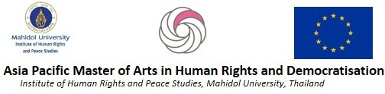

REFERENCE FORM

Dear Referee,

Greetings! We hope you are well.

We would like you to fill out this form as a reference person for an individual applying for the Asia Pacific Master of Arts in Human Rights and Democratisation (APMA) programme. We welcome any comments that you can make regarding the applicant.

Aside from this form, please attach a one-page comment on the applicant’s ability suitability to undertake a master’s program. In particular, we will appreciate your genuine assessment of the applicant’s ability to undertake a research project and to produce academic papers, and their interest in human rights. Please attach your comment to this form.

- Name of Applicant | ______________________________________________________
- I have known the applicant for | ____ years
in their capacity as: | ______________________________________________________
- In the box below rate the applicant’s academic abilities. Please tick the appropriate box:
 | Top 10% | Above Average | Average | Below Average | Poor | Don’t know
Academic ability
Written expression
Research ability
Practical Experience
Ability to work independently
Motivation for study
Knowledge of human rights

- How would you rate the applicant’s proficiency in spoken and written English?

- Referee Details
Name:
Position:
Institution:
Address:
Institutional Email:
Telephone:
Signature: |  | Date:

Please note, we may contact you for further information about the applicant. Our thanks!
Please send this document in pdf format to: ihrpmhrd@mahidol.edu.

Subject line should be: APMA2020<space>Reference<space>Your Name</>Name of Applicant

